ABSTRACT
CRISPR is a powerful genome editing technology widely used in biotechnology and molecular biology for precise modification of DNA sequences. The efficiency of this system mainly depends on the accurate design of guide RNA (gRNA), which directs the Cas9/Cas12 enzyme to the specific target site in the genome.
In this mini project, guide RNA design was carried out using bioinformatics databases and software tools including NCBI, SnapGene, and CHOPCHOP. The target gene sequence was retrieved from the NCBI database and analysed using SnapGene for sequence visualization and editing. The processed sequence was then submitted to CHOPCHOP to identify suitable guide RNA candidates based on PAM sequence recognition, GC content, target specificity, and off-target prediction.
This project demonstrates the application of bioinformatics tools in designing efficient guide RNAs for CRISPR-mediated genome editing and highlights the importance of computational approaches in modern genetic engineering research.

INTRODUCTION
CRISPR (Clustered Regularly Interspaced Short Palindromic Repeats) is an advanced genome editing technology derived from the natural defense mechanism of bacteria against viral infections. It enables scientists to modify DNA sequences with high precision and efficiency, making it one of the most significant tools in modern biotechnology and genetic engineering.
Among the different CRISPR-associated proteins, Cas9 and Cas12 are widely used nucleases for genome editing applications. CRISPR-Cas9 is the most commonly used system in which the Cas9 enzyme creates a double-stranded break at a specific DNA target directed by a guide RNA (gRNA). Cas9 recognizes a PAM (Protospacer Adjacent Motif) sequence, typically “NGG,” which is essential for target binding and cleavage.
CRISPR-Cas12, also known as Cpf1, is another important CRISPR nuclease that differs from Cas9 in several aspects. Cas12 recognizes a T-rich PAM sequence and produces staggered DNA cuts instead of blunt ends. It also requires only a single CRISPR RNA (crRNA) for target recognition, making it useful for various genome engineering and diagnostic applications.
The success of CRISPR-mediated genome editing largely depends on the accurate design of guide RNA molecules. In this mini project, guide RNA design was carried out using bioinformatics resources and software tools including NCBI, SnapGene, and CHOPCHOP. The target gene sequence was retrieved from the NCBI database, analyzed using SnapGene, and suitable guide RNAs were designed using CHOPCHOP based on target specificity, PAM sequence, GC content, and off-target analysis.
This project highlights the importance of computational tools in designing efficient guide RNAs for CRISPR-Cas9 and CRISPR-Cas12 genome editing systems.

OBJECTIVES OF THE STUDY
- To understand the basic principle and mechanism of CRISPR-Cas9 and CRISPR-Cas12 genome editing systems.
- To retrieve the target gene sequence from the NCBI database.
- To analyze and visualize the DNA sequence using SnapGene.
- To design suitable guide RNA (gRNA) sequences using CHOPCHOP.
- To identify PAM sequences and evaluate guide RNA specificity.
- To study important parameters involved in guide RNA design such as GC content, target efficiency, and off-target effects.
- To understand the application of bioinformatics tools in genome editing and genetic engineering research.
MATERIALS AND SOFTWARE USED
  - Homo sapiens Tp53 gene
  - NCBI
  - SnapGene
  - CHOPCHOP

METHODOLOGY
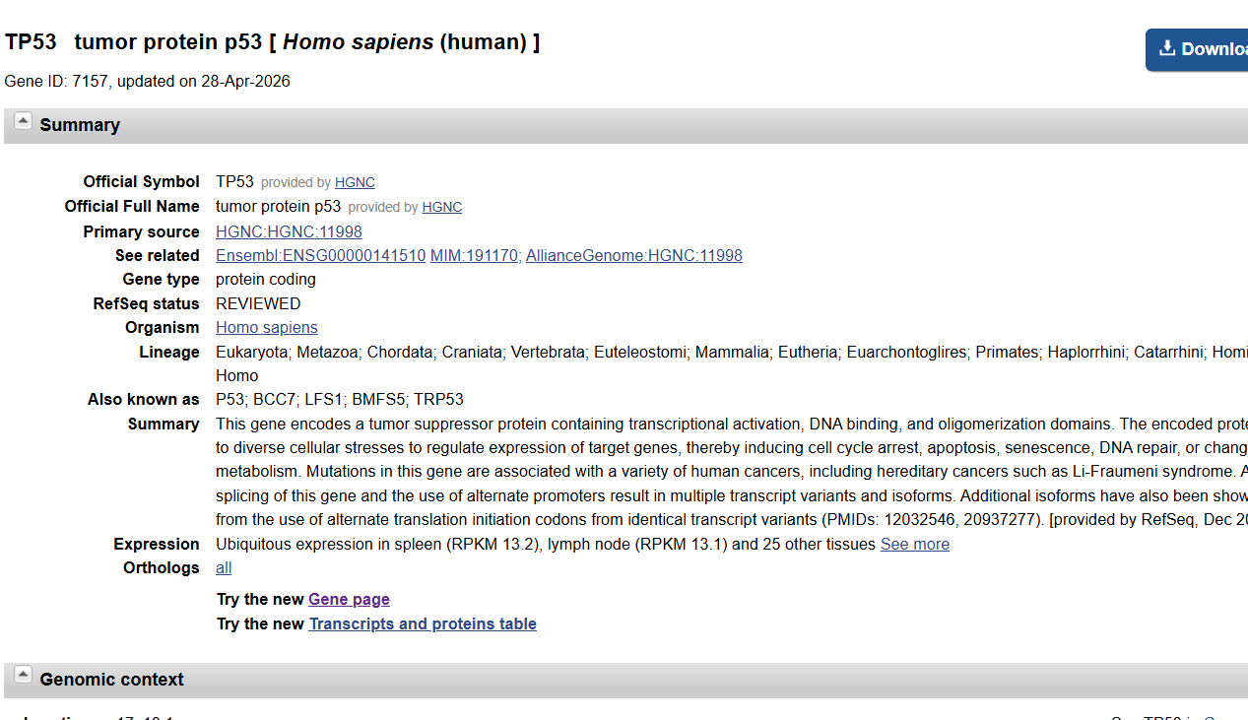
- Check a gene from NCBI database -Tp53 Tumor
- Download the Gene Sequence as FASTA File
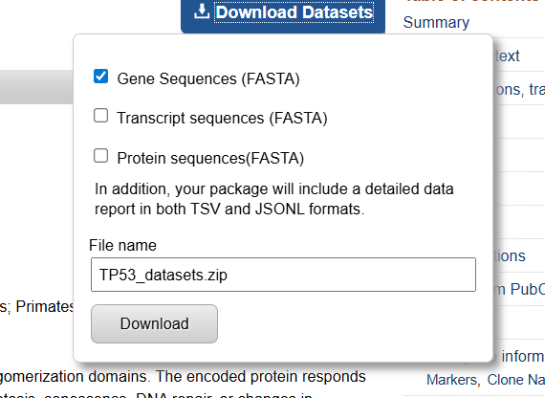

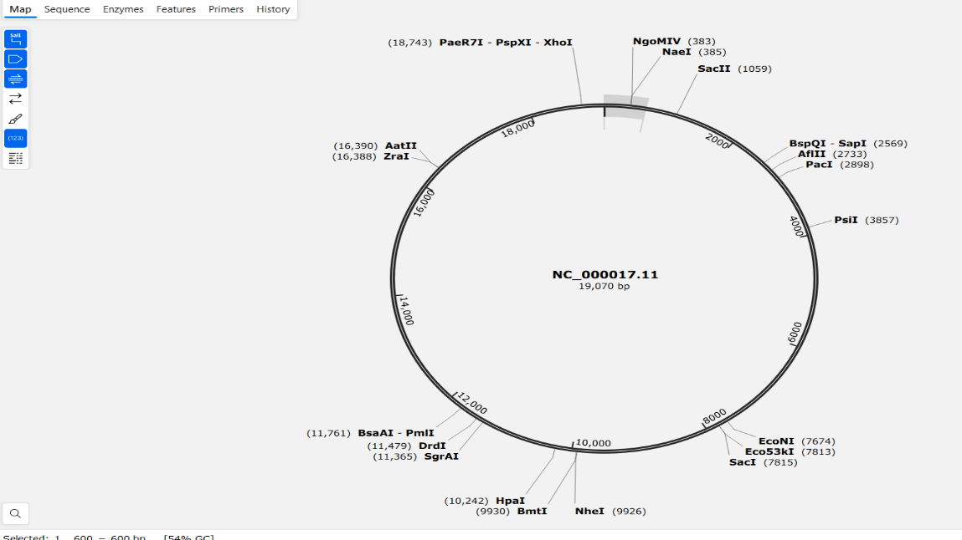
- Import the Gene Sequence directly to the Snapgene

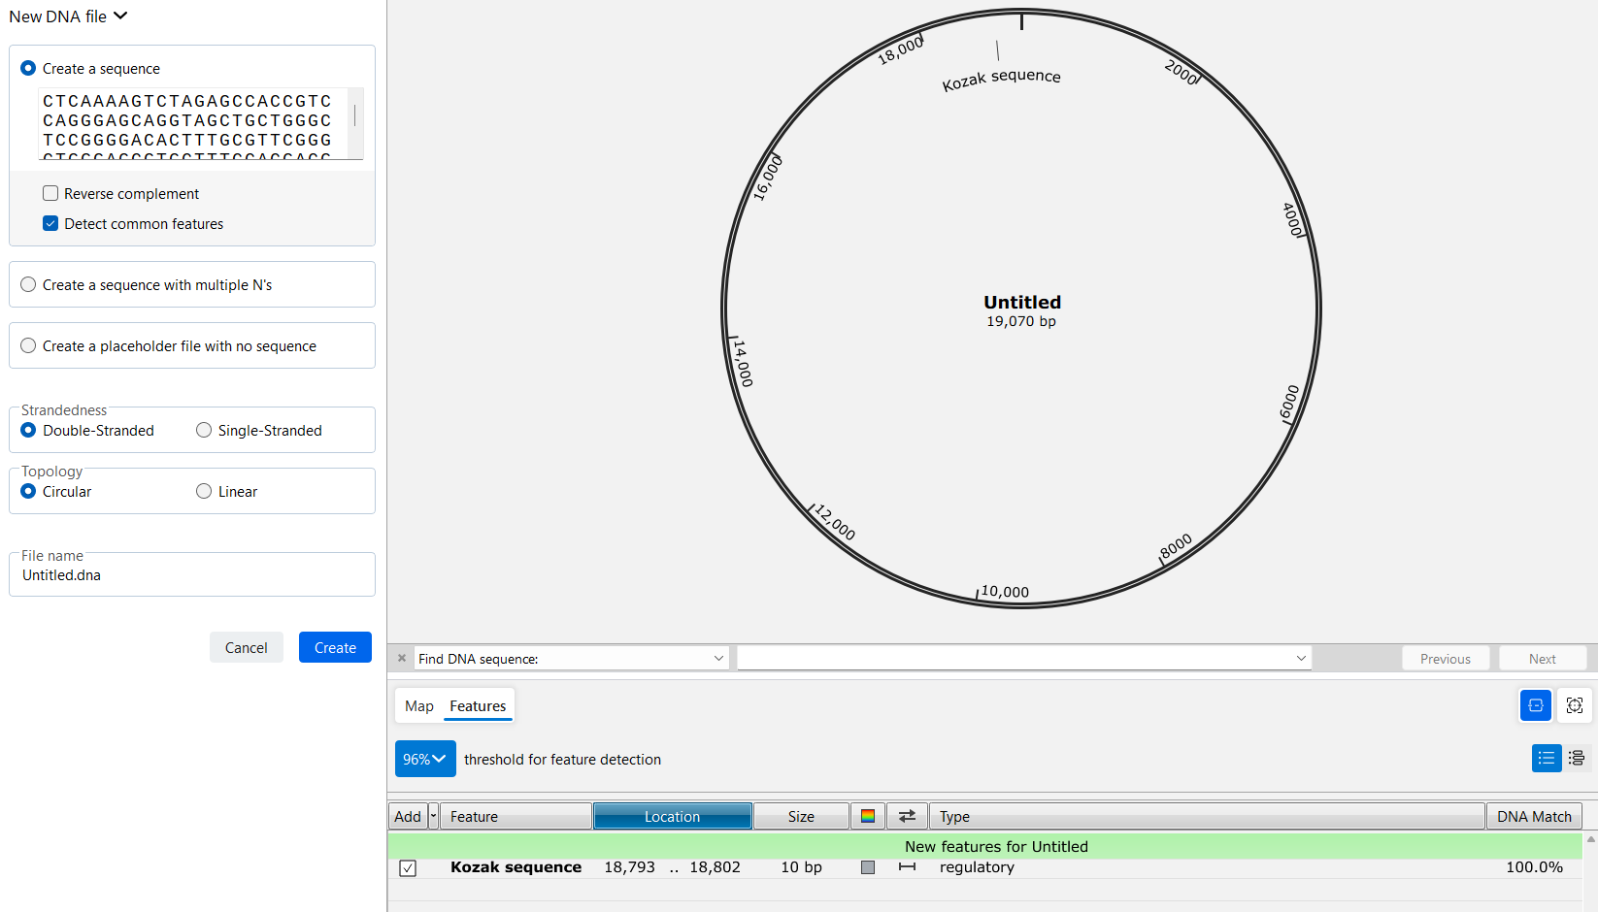
Or, Open the FASTA file in the NOTEPAD – Then Copy the Gene Sequence in SnapGene -> Create a New File -> Create.

- Change the Gene visual Map to Sequence Format
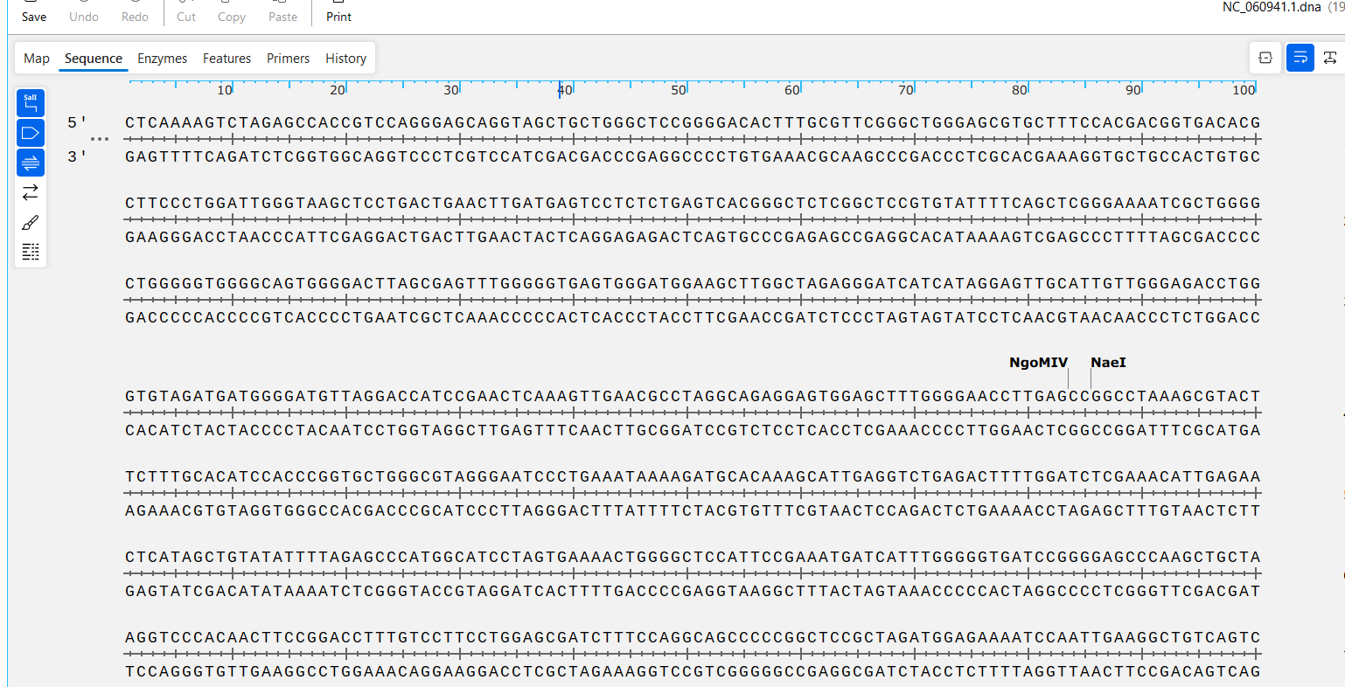

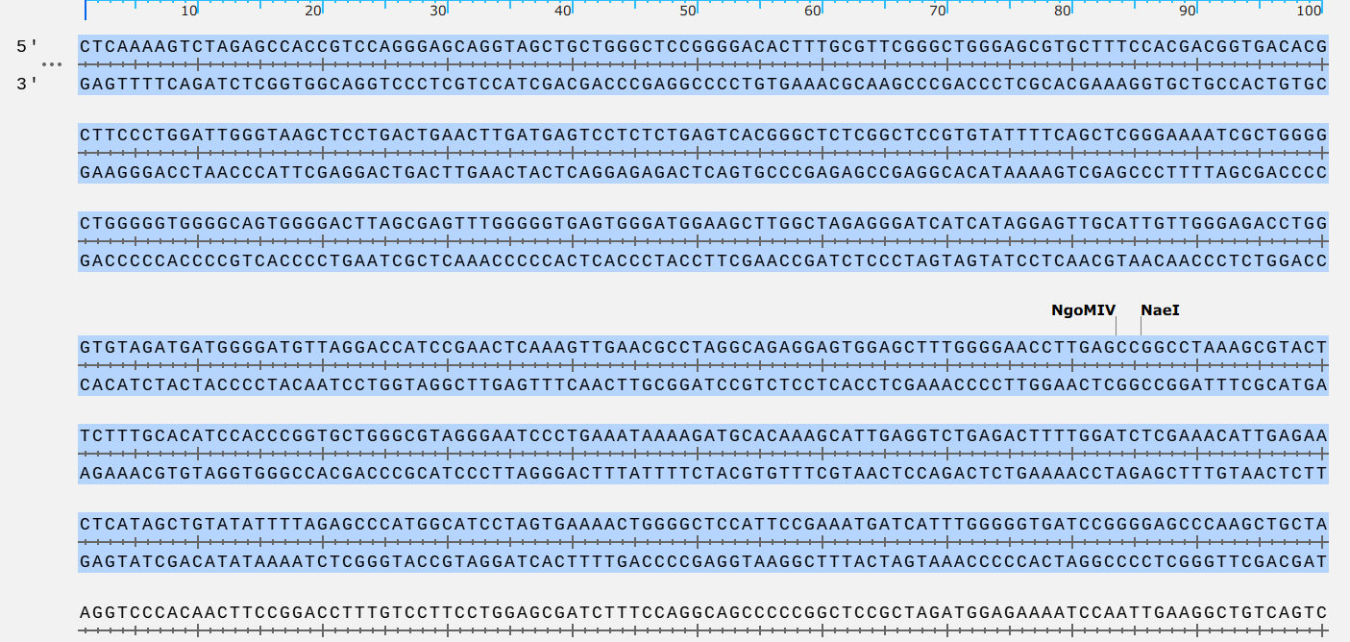
- Then Select a part(500-600bp) of the sequence or the full Sequence

- Copy the Sequence and Paste in the CHOPCHOP website.
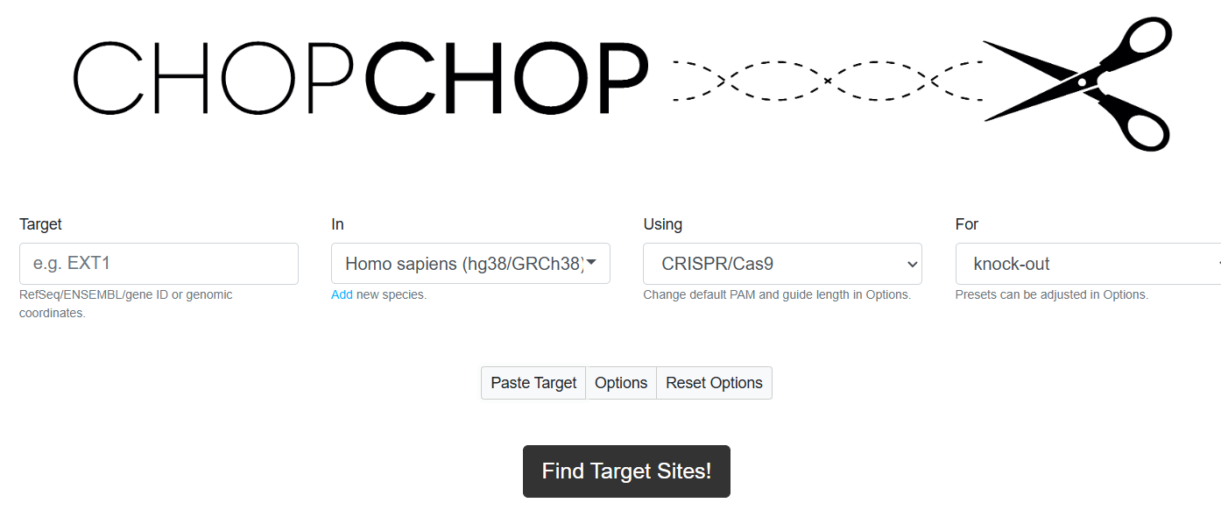
Open Google-> CHOPCHOP-> Click “PASTE TARGET”.

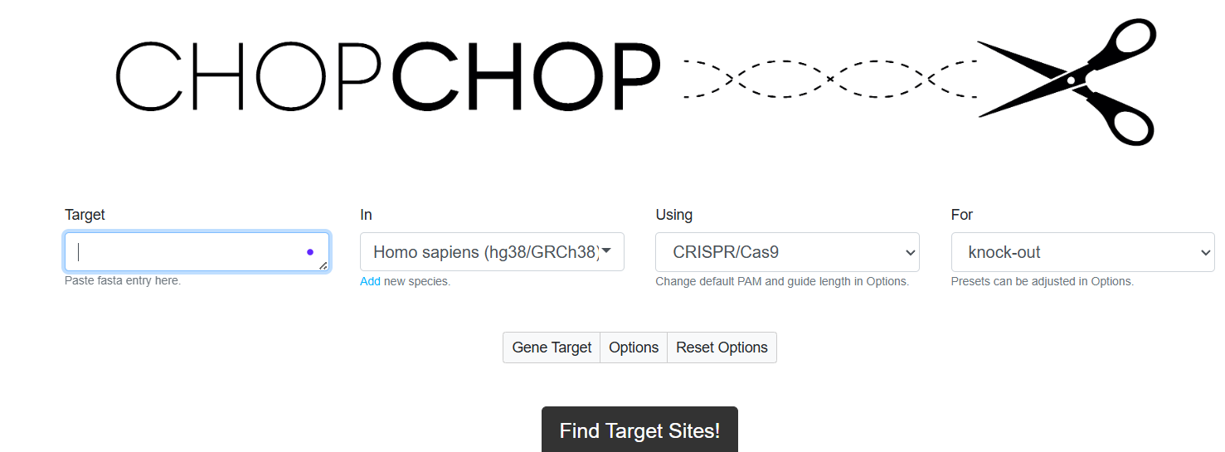

- Paste The copied Sequence from SanpGene . Set required Parameters.
Parameters: -
    - Target – Paste the sequence
    - In – Homo Sapiens (Choose from where the Sample taken)
    - Using – CRISPR/Cas-9
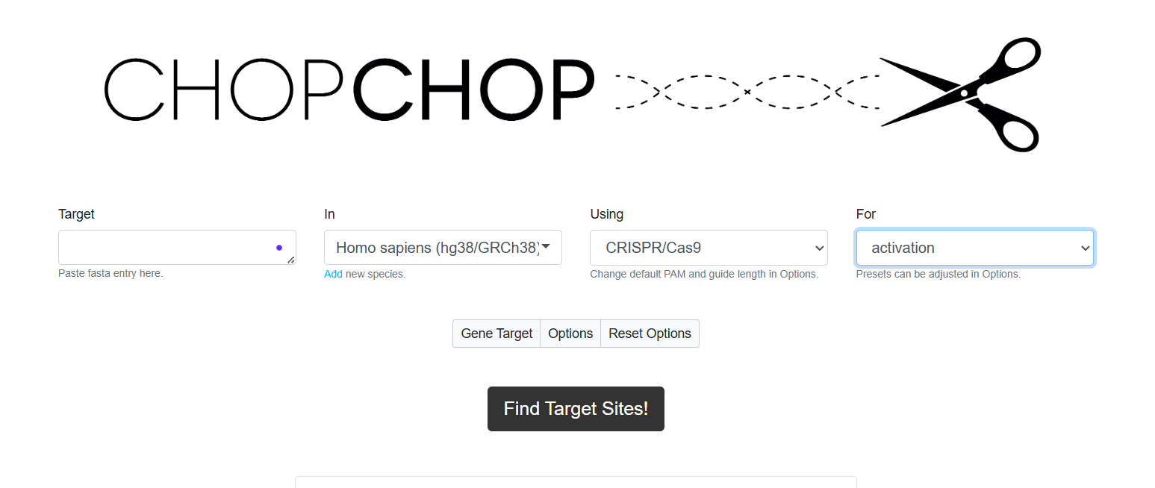
    - For – Activation -> then Go for the “Option” box.
- Then Check for the Options -> Click On the “Find Target Site”.
- Click on Option -> Cas9
- sgRNA length Without PAM – 20
- PAM3 – NGG

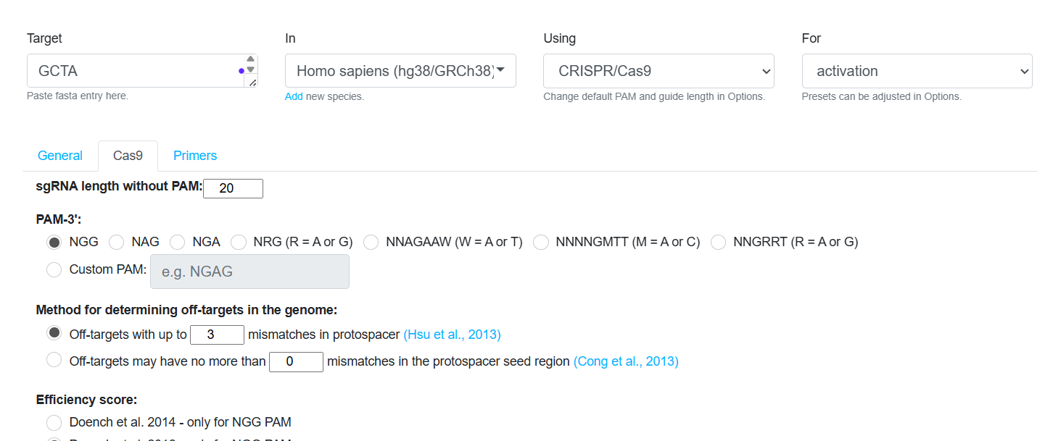



- Collection Of Varieties Of Guide RNA + PAM Sequence are listed.
( 23 bp sequence = 20bp (gRNA)+ 3bp (PAM))
      - Download - Result Table as .tsv
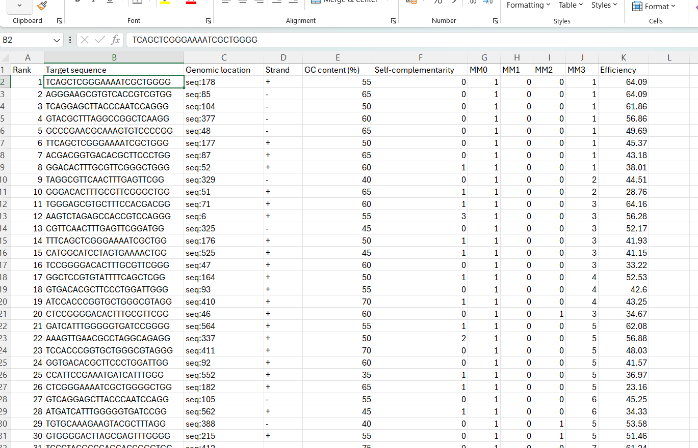
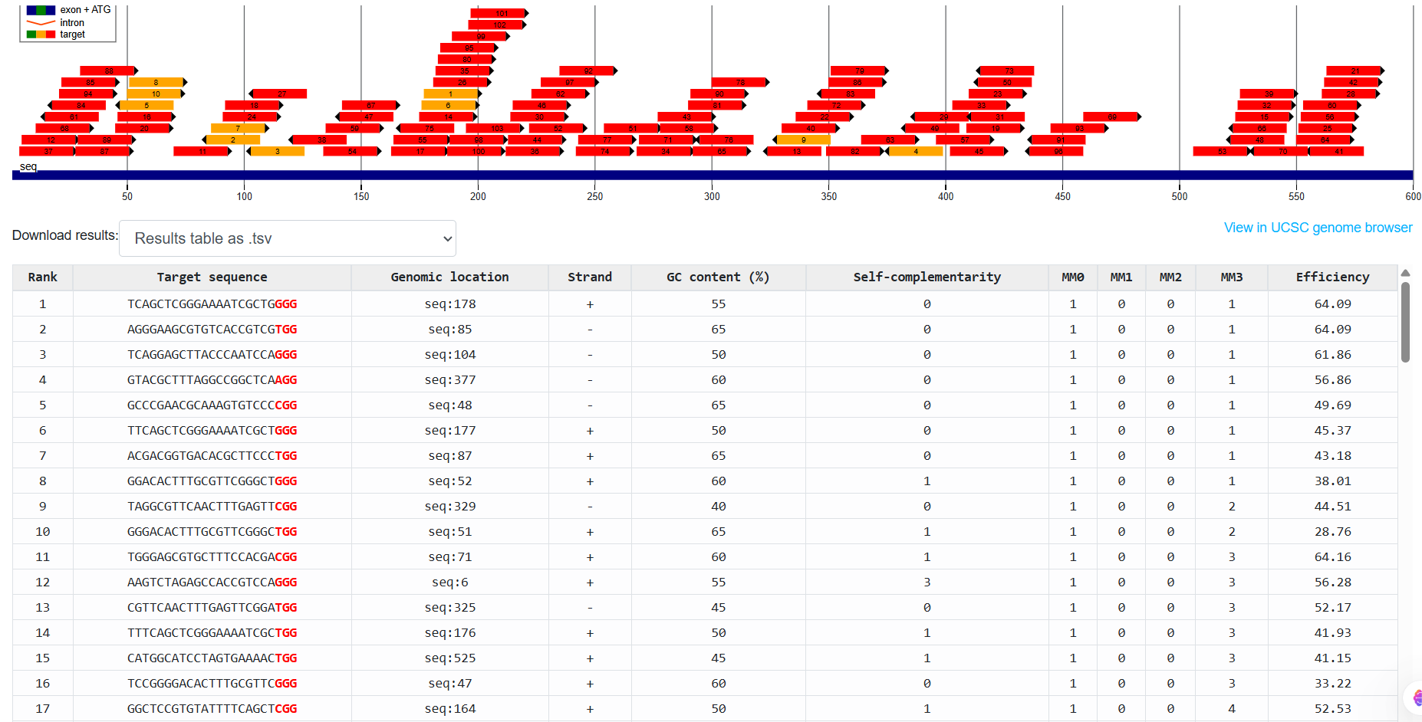
      - Open In EXCEL -> Filter the Best Sequence.

- Filter the Sequence according to the following Criteria.
- GC content % = 40 < GC >= 60
- Self-Complementarity = 0
- MM0 = 1
- MM1 = 0
- MM2 = 0
- MM3 = 1
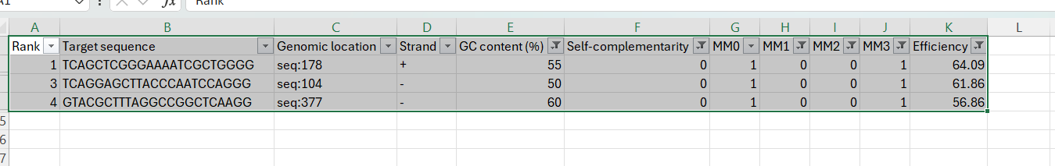
- Efficiency = > 50 = Good, > 70 = Best
- Now we have our three best Guide RNA sequence to visualize in SnapGene
- Copy one of the Sequence
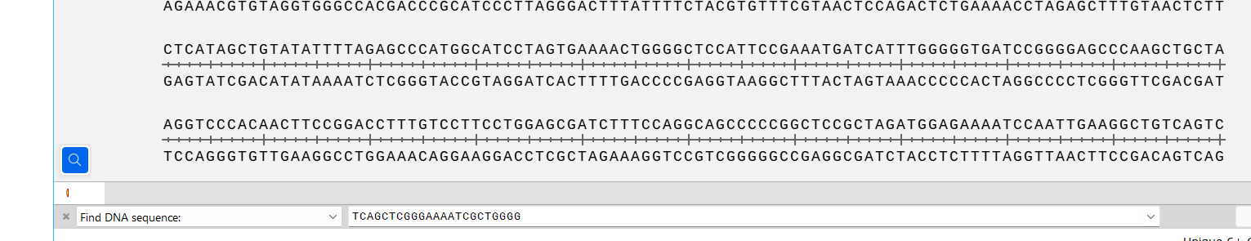
- Then put in the “Find DNA sequence”.

- Automatically, the given Sequence was highlighted.

- Now, “Add Features” to the Sequences like the direction, Colour, gRNA,PAM.
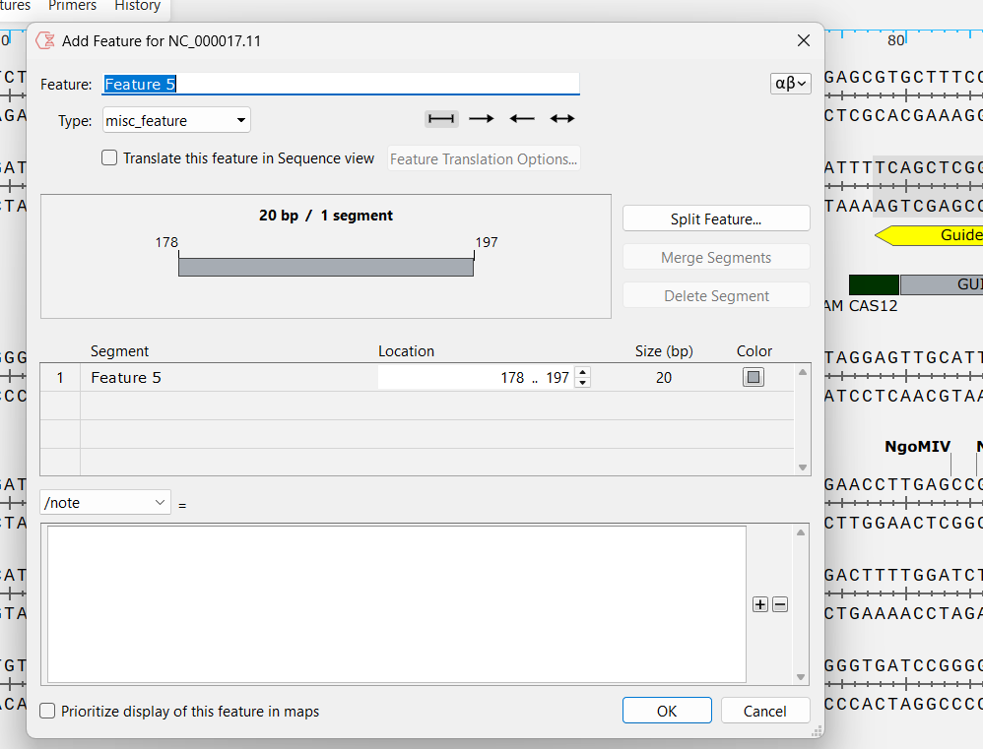

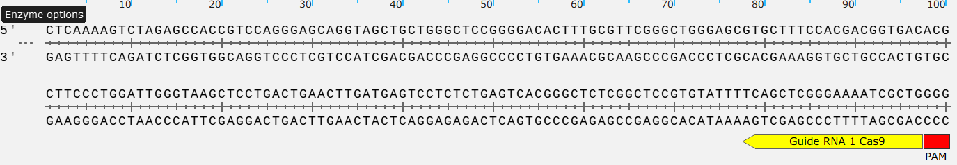
- Now, This is the gRNA sequence and PAM for our Target Gene.
- Above we have got for the CRISPR Cas9 but we can also do this process for Cas12 also. This process is quite similar as Cas9.
- Take the gene -> download FASTA-> copy the sequence /open in SnapGene.
- Now take the part of the sequence -> paste in CHOPCHOP.
- Select the option ->using- Cas12/CasX.
- Set the criteria ->cpf1= sequence-20, 5’PAM= TTTN
- We will got some 23bp Sequences.
- Export to the Excel ->Filter the sequence->copy the sequence -> paste in the “Find the DNA”.
- The sequence will be highlighted-> add Features .
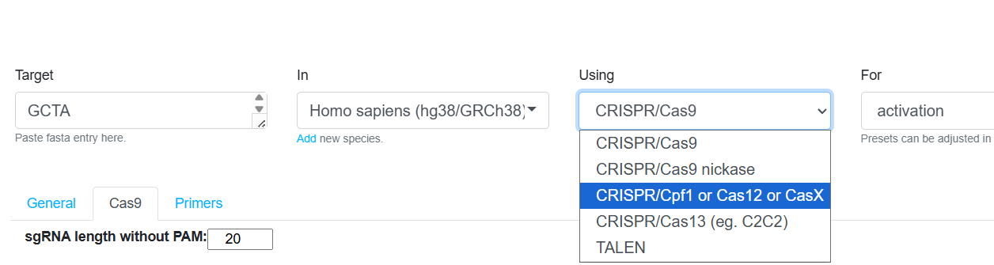
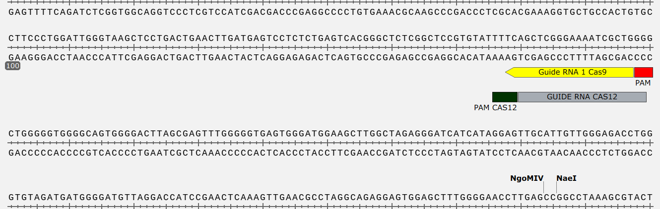
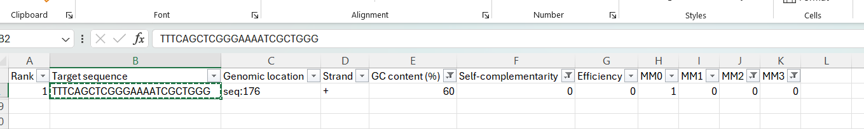
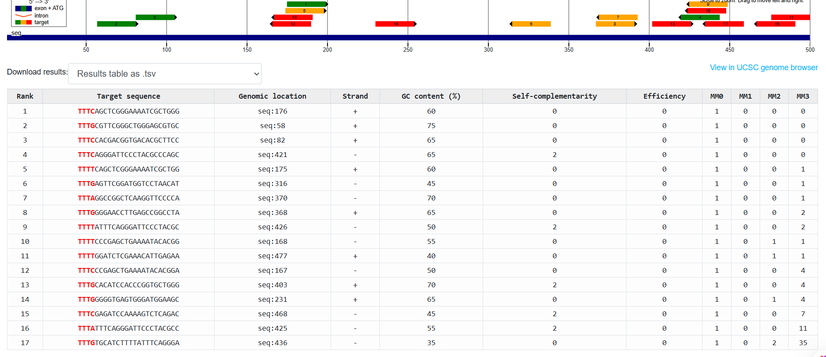
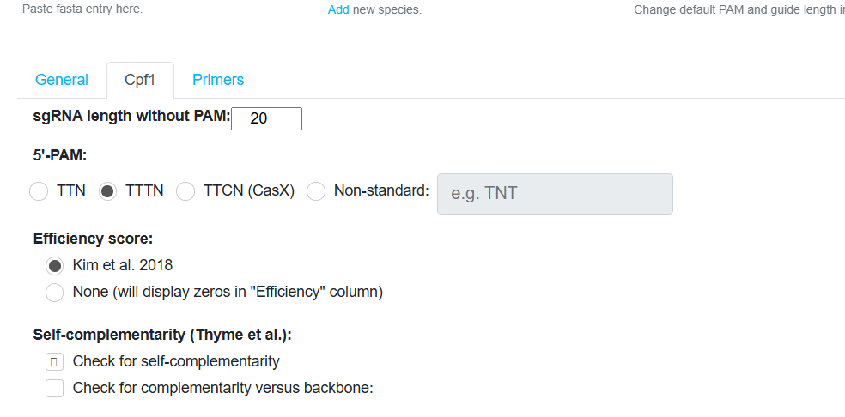

RESULTS
The target gene sequence was successfully retrieved from NCBI and analyzed using SnapGene. The selected DNA region was exported and used for guide RNA design in CHOPCHOP.
Multiple guide RNA (gRNA) candidates were generated for both CRISPR-Cas9 and CRISPR-Cas12 systems. The designed gRNAs were evaluated based on:
- PAM sequence presence
- Efficiency score
- GC content
- Self-complementarity
- Off-target mismatch analysis (MM0–MM3)
Guide RNAs with high efficiency scores, low self-complementarity, and minimal off-target effects were selected as suitable candidates for genome editing applications. The study demonstrated that bioinformatics tools can effectively assist in accurate and reliable guide RNA design.
APPLICATIONS OF CRISPR TECHNOLOGY
- Gene Editing
Used for precise modification, deletion, or insertion of genes in organisms.
- Disease Treatment
Applied in research for genetic disorders such as sickle cell anemia, cystic fibrosis, and cancer.
- Agricultural Biotechnology
Used to develop disease-resistant, drought-tolerant, and high-yield crop varieties.
- Drug Discovery
Helps identify gene functions and therapeutic targets in biomedical research.
- Functional Genomics
Used to study gene expression and biological pathways.
- Diagnostic Applications
CRISPR-Cas12 systems are widely used in rapid molecular diagnostics and pathogen detection.
- Microbial Engineering
Used to improve industrial microorganisms for biotechnology and biofuel productio

